PROJECT REPORT

**Fertilizers Recommendation System for Disease**

**Prediction**

## TEAM ID: PNT2022TMID12969 TEAM LEADER: SUNIL NAATH A TEAM MEMBER 1: HARISH K

**TEAM MEMBER 2: MADESHWARAN R V TEAM MEMBER 3: RAM KUMAR B**

# INTRODUCTION :

Disease prediction in plants is used to detect and recognize the plant diseases. The disease may lead to abnormal functionalities which may lead to the death of the plant. Computer vision and image processing are used to capture and analyze images of the plants andtheir parts like leaves. By analyzing the images, based on certain symptoms like yellowing of leaves, curling, black spots, etc., the deficit nutrients that lead to the disease are found. Based on the available data on fertilizers, the necessary nutrient rich fertilizers are recommended.

## PROJECT OVERVIEW:

An Automated system is introduced to identify different diseases on plants by checking the symptoms shown on the leaves of the plant. Deep learning techniques are used to identify the diseases and suggest the precautions that can be taken for those diseases changes in cultivation method and inadequate plant protection techniques and suggest all the precautions that can be taken for those diseases.

## PURPOSE:

* To Detect and recognize the plant diseases and to recommend fertilizer, it is necessary to identify the diseases and to recommend to get different and useful features needed for the purpose of analyzing later.
* To provide symptoms in identifying the disease at its earliest. Hence the authors proposed and implemented new fertilizers Recommendation System for Crop Disease Prediction.

## LITERATURE SURVEY:

* 1. **EXISTING PROBLEM:**

### Prediction of crop yield and fertilizer recommendation using machine learning algorithms

**Advantage**: It recommends fertilizer suitable for every particular crop.

**Disadvantage:** Requires Third Party applications to display information on weather, temperature, humidity, atmospheric pressure, etc.

**Algorithm used**: Random Forest and Support Vector Machine algorithms are used for the classification of the soil to classify, display confusion matrix, Precision, Recall, predict crop based on the given inputs, etc.

### Plant Infection Detection Using Image Processing

**Advantage**: This system was capable of identifying the infection and classifies them accordingly with 98.27% of accuracy.

**Disadvantage**: The farmers must afford mobile phones or digital camera to take images of infected leaves of different plants.

**Algorithm used:** Infections are detected based on K-meansclustering and GLCM techniques. GLCM is used for texture analysis, while K-mean segmentation technique uses hue estimation method for dividing and clustering the image.

### Fertilizers Recommendation System for Disease Prediction in Tree Leaves

**Advantages:** Recommend the fertilizer for affected leaves and its measurement or quantity are suggested based on severity level of the disease.

**Disadvantage**: The proposed algorithm cannot be used to identify the disease that affects the other plant organs such as stems and fruits.

**Algorithm used:** Support Vector Machine (SVM) algorithm classifies the leaf image as normal or affected. And it is used to identify a function Fx which obtain the hyper-plane.

### Plant Disease Detection Using Image Processing and Machine Learning

**Advantage:** Accuracy scores were 93% which is nearly equal to f1 scores. It requires less time for prediction than other deep learning-based approaches since it uses statistical machine learning and image processing algorithm.

**Disadvantage**: The proposed system is able to detect 20 different diseases only.

**Algorithm used:** Random Forest classifier, a combinationof multiple decision trees is used where each tree is trained by using different subsets of the whole dataset to reduce the overfitting and improves the accuracy of the classifier.

### Cloud Based Automated Irrigation and Plant Leaf Disease Detection System Using an Android Application.

**Advantage**: It is simple and cost-effective system for plant leaf diseasedetection.

**Disadvantage:** Any H/w failures may affect the system performance.

**Algorithm used**: K-means clustering is used for feature extraction.

* **Farmer’s Assistant: A Machine Learning Based Application for Agricultural Solutions Advantages**: It is expected that boosting (Random Forest) and bagging (XG Boost) models will usually perform and generalize better than non-ensemble methods.

**Disadvantage**: This model performs well only on the images which are from those classes that the model already knows and it will not be able to detect the correct class for any data that is out of the domain.

**Algorithm used**: XG Boost, which stands for Extreme Gradient Boosting, is a scalable, distributed gradient-boosted decision tree (GBDT) machine learning library. It provides parallel tree boosting and is the leading machine learning library for regression, classification, and ranking problems. Random forest algorithm is also used.

## 2.2-References :

* G. Preethi, P. Rathi, S. M. Sanjula, S. D. Lalitha, B. V. Bindhu, “Agro based cropand fertilizer recommendation system using machine learning”, European Journal of Molecular & Clinical Medicine, 7, 4, 2020, 2043-2051 https://deepai.org/publication/farmer-s-assistant-a-machine- learning-based- application-foragricultural-solutions
* International Journal of Engineering Applied Sciences and Technology, 2019 Vol. 4, Issue 5, ISSN No. 2455-2143, Pages 371-376 https:/[/www.ij](http://www.ijeast.com/papers/371-)e[ast.com/papers/371-](http://www.ijeast.com/papers/371-) 376,Tesma405,IJEAST.pdf
* Plant Disease Detection Using Image Processing and Machine Learning Pranesh Kulkarni1 , Atharva Karwande1, Tejas Kolhe1, Soham Kamble1, Akshay Joshi1, Medha Wyawahare, Department of Electronics and Telecommunication, Vishwakarma Institute of Technology.

\https://arxiv.org/ftp/arxiv/papers/2106/2106.10698.pdf

* Plant Infection Detection Using Image Processing - Senthilkumar Meyyappan, NallaMalla Reddy Engineering college, Corresponding Author: Dr. Sridhathan C https:/[/www.rese](http://www.researchgate.net/publication/326803995_Plant_Infection_Detection_Us)a[rchgate.net/publication/ 326803995_Plant_Infection_Detection_Us](http://www.researchgate.net/publication/326803995_Plant_Infection_Detection_Us) ing_Image_Processing.
* Plant Disease Detection Using Image Processing DOI10.1109/ICCUBEA.2015.153 https://ieeexplore.ieee.org/document/7155951
* Metrics for Performance Measurements - https:/[/www.mathworks.com/matlabc](http://www.mathworks.com/matlabcentral/answers/418986-how-to-calculate-)e[ntral/answers/](http://www.mathworks.com/matlabcentral/answers/418986-how-to-calculate-) [418986-how-to-calculate-](http://www.mathworks.com/matlabcentral/answers/418986-how-to-calculate-)truepositive-true-negative-false-positive-and-false-negative-as-we- have-segment
* International journal of scientific & technology research volume 8, issue 11, November 2019 ISSN 2277-8616 3343 Fertilizers Recommendation System for Disease Prediction In Tree Leaf. <http://www.ijstr.org/final>[-print/nov2019/Fertilizers-](http://www.ijstr.org/final-print/nov2019/Fertilizers-)Recommendation-System-ForDisease- Prediction-In-Tree-Leave.pdf

## 2.3-PROBLEM STATEMENT DEFINITION:

Mr.Narasimma Rao is a 65 years old man. He had an own farming land and do Agriculture for past 30 years In this 30 Years he Faced a problem in Choosing Fertilizers and Controlling of Plant Disease.

* Narasimma Rao wants to know the better recommendation for fertilizers for plants with the disease.
* He has faced huge losses for a long time.
* This problem is usually faced by most farmers.
* Mr. Narasimma Rao needs to know the result immediately. Who does the problem affect?

# IDEATION & PROPOSED SOLUTION :

## Empathy Map canvas:

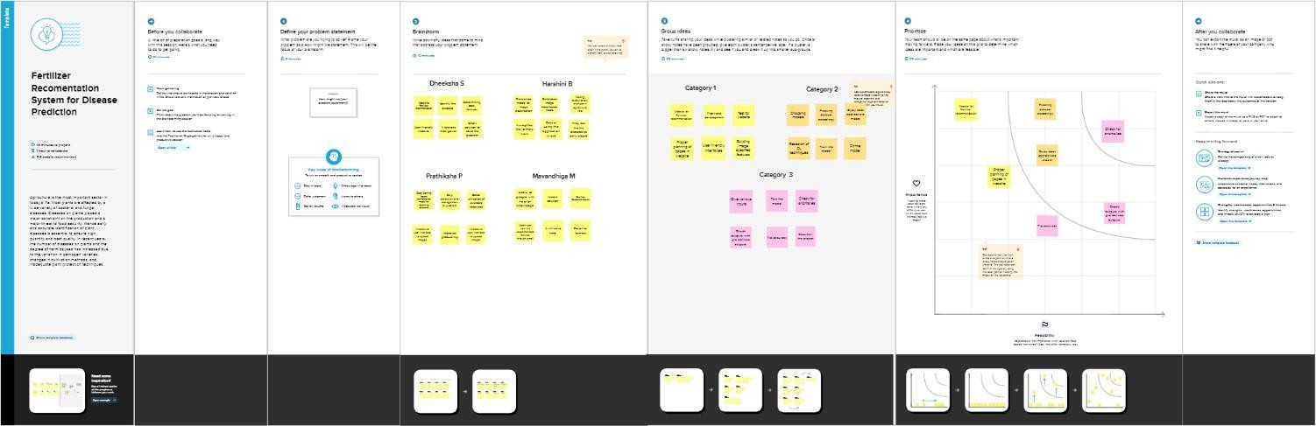

* 1. **Ideation and Brainstorming:**

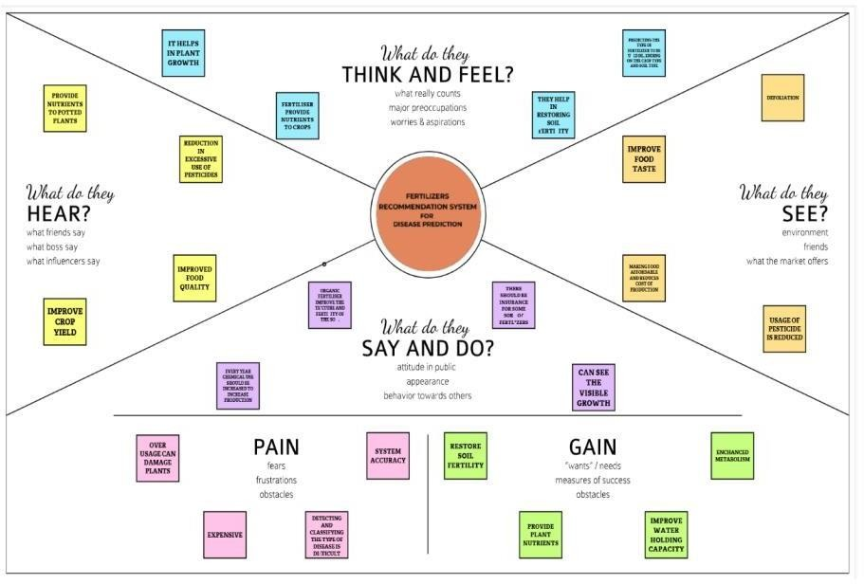

## 3.3-Proposed Solution:

Project team shall fill the following information in proposed solution template.

|  |  |  |
| --- | --- | --- |
| **S. No.** | **Parameter** | **Description** |
| 1. | Problem Statement (Problem to be solved) | Agriculture is having a great impact on the country’s economy. Different diseases effectplant that reduces their production and is a major threat to food security. The major problems that the farmers of our country are currently facing includes Crop Failure, Lack of adequate knowledge, Crop damage due to ignorance/carelessness, Lack of professional assistance, Inaccessibility to agro-tech solutions. Most of the diseases are detected in later stage that to manually which is time consuming and results in heavy loss so it is important to build an automated system that detects disease at early stage and provides fertilizer recommendation  accordingly. |
| 2. | Idea / Solution description | An automated system is built that takesthe input as picture of leaves which is uploaded by the user, identifies differentdiseases on plants by checking the symptoms shown on the leaves of the plant. Deep learning techniques are used to identify the diseases and suggest the fertilizer needed for the  plant. |
| 3. | Novelty / Uniqueness | It does not require user to consult any specialist for identification of diseases that affected the leaves and the fertilizers that is required for the  same. It detects Plant disease at their early stage. |
| 4. | Social Impact/Customer Satisfaction | The whole process of identifying disease and recommendation of fertilizer happens just by uploading image so it is user friendly. It helps farmers to get good yield out of the crop. People will get goodquality  food products. |
| 5. | Business Model (Revenue Model) | Social media is the best way to spread the word about our application. And with the influencers we can reach out to people. Clustering and targeting the farmers for identifying diseases on their plants and recommending themfertilizers for  the same |
| 6. | Scalability of the Solution | It can be used in research areas to study about the diseases in plant and the best fertilizer that can be recommended for it among the list of fertilizers  available .It can be used by anyone in the world |

**3.4-Problem Solution fit:**

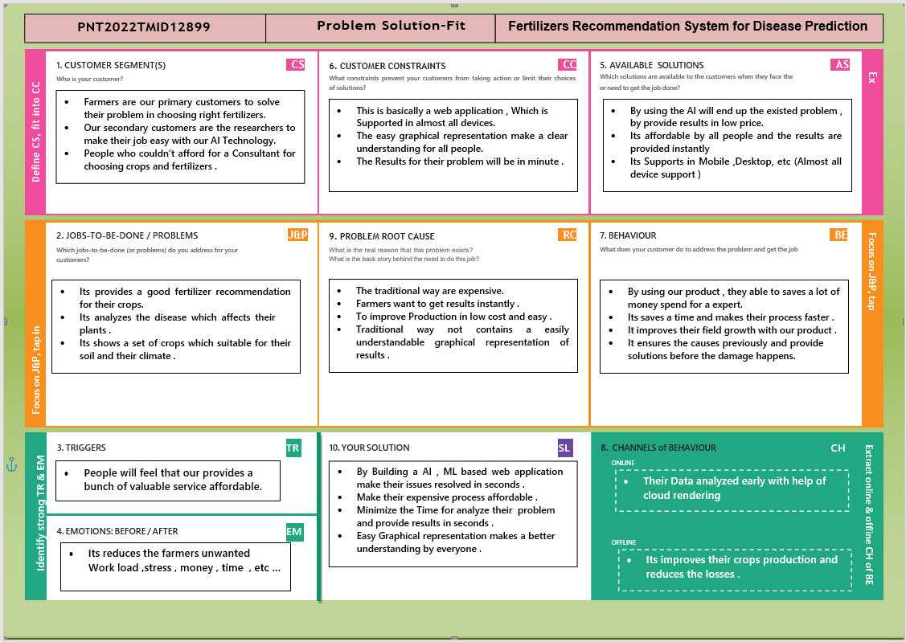

# REQUIREMENT ANALYSIS:

## Functional Requirements:

These are the functional requirements of the proposed solution.

|  |  |  |
| --- | --- | --- |
| **FR No.** | **Functional Requirement** | **Sub Requirement (Story / Sub-task)** |
| **FR-1** | User Registration | Registration through form |
| **FR-2** | User Confirmation | Confirmation via Email |
| **FR-3** | User Profile | Filling the profile page after logging in |
| **FR-4** | Uploading Dataset(Leaf) | Images of the leaves are to be uploaded |
| **FR-5** | Requesting solution | Uploaded images are compared with the pre-defined Model and solution is generated |
| **FR-6** | DownloadingSolution | The Solution in pdf format which contains the recommendations of fertilizes and thepossible diseases. |

## Non-functional Requirements:

Following are the non-functional requirements of the proposed solution.

|  |  |  |
| --- | --- | --- |
| **FR No.** | **Non-Functional Requirement** | **Descriptionn** |
| **NFR-1** | Usability | The system allows the user to perform the tasks easily and efficiently and effectively. |
| **NFR-2** | Security | Assuming all data inside the system of its partwill be protected against malware attacks of unauthorized access. |
| **NFR-3** | Reliability | the website does not recover from failure quickly, it  takes time as the application is running in single server |
| **NFR-4** | Performance | Response Time and Net Processing Time is last |
| **NFR-5** | Availability | The system will be available up to 95% of thetime |
| **NFR-6** | Scalability | The website is scalable |

# PROJECT DESIGN

## Data Flow Diagram

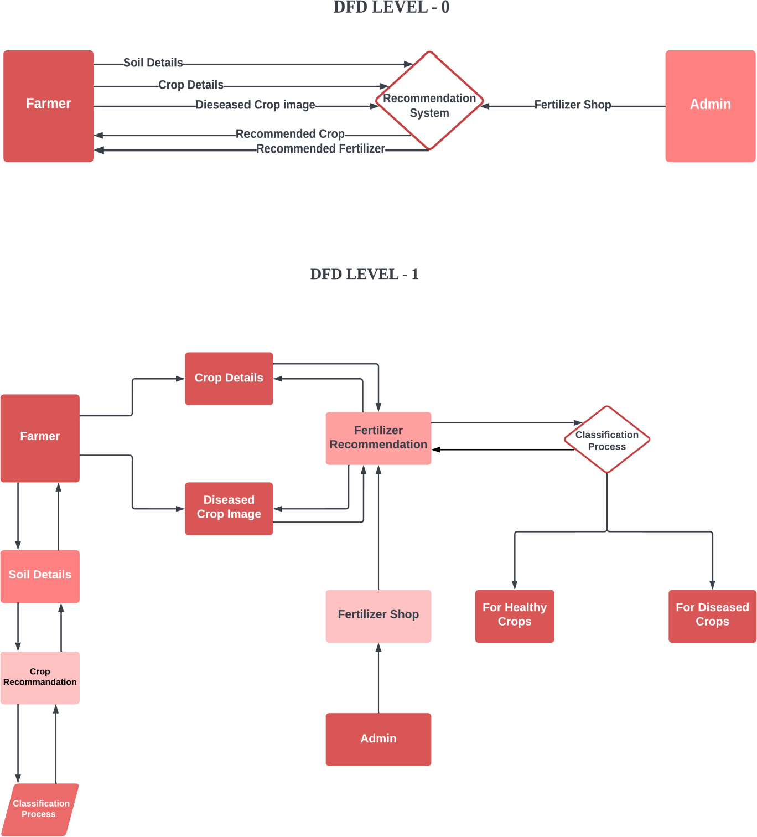

* 1. **SOLUTION & TECHNICAL ARCHITECTURE**

### Table 1: Components & Technologies:

|  |  |  |  |
| --- | --- | --- | --- |
| **S. No** | **Component** | **Description** | **Technology** |
| 1. | User Interface | How user interacts with application e.g. Web UI, Mobile App, Chatbot etc. | HTML, CSS, JavaScript/ Angular Js/React Js etc. |
| 2. | Application Logic-1 | Logic for a process in the application | Java / Python |
| 3. | Application Logic-2 | Logic for a process in the application | IBM Watson STT service |
| 4. | Application Logic-3 | Logic for a process in the application | IBM Watson Assistant |
| 5. | Database | Data type, Configurations etc. | MySQL, NoSQL, etc. |
| 6. | Cloud Database | Database Service on Cloud | IBM DB2, IBM  Cloudant, etc. |
| 7. | File Storage | File storage requirements | IBM Block Storage or other Storage Service or Local Filesystem |
| 8. | External API-1 | Purpose of External API used in the application | IBM Weather API,etc. |
| 9. | External API-2 | Purpose of External API used in the application | Aadhar API, etc. |
| 10. | Machine Learning Model | Purpose of Machine Learning Model | Object Recognition Model, etc. |
| 11. | Infrastructure (Server / Cloud) | Application Deployment on LocalSystem / Cloud Local Server Configuration: Cloud Server Configuration : | Local, Cloud Foundry, Kubernetes, etc. |

**Table 2: Application Characteristics:**

|  |  |  |  |
| --- | --- | --- | --- |
| **S.No.** | **Characteristics** | **Description** | **Technology** |
| 1. | Open-Source Frameworks | List the open-source frameworks used | Technology of Open Source Framework |
| 2. | Security Implementations | List all the security / access controls implemented, use of firewalls etc. | e.g. SHA-256, Encryptions, IAM Controls, OWASP  etc. |
| 3. | Scalable Architecture | Justify the scalability of architecture  (3–tier, Micro-services) | Technology Used |
| 4. | Availability | Justify the availability of application (e.g. use of load balancers, distributed  servers etc.) | Technology used |

## User Stories:

|  |  |  |  |  |  |  |
| --- | --- | --- | --- | --- | --- | --- |
| **UserType** | **Functional Requirement (Epic)** | **User Story Number** | **User Story / Task** | **Acceptance criteria** | **Priority** | **Release** |
| **Customer (Mobile user)** | Registration | USN-1 | As a user, I can register for the application by entering my email, password, and confirming my password. | I can access my account / dashboard | High | **Sprint**  **-1** |
|  | Login | USN-2 | As a user, I can log into the application by entering email & password | I can login using my E- mail ID accounts or user credentials | High | **Sprint**  **-1** |
|  | Dashboard | USN-3 | As a user, I can view the page ofthe application where, I can upload myimages and the fertilizer should be  needed | I can access my account/dashboard | High | **Sprint**  **-2** |
| **Custom er (Webuser)** | Registration | USN-4 | As a user, I can login to web dashboard just Like website dashboard | I can register using my username and password | High | **Sprint**  **-3** |
|  | Login | USN-5 | As a user, I can login to my web dashboard with the login credentials | I can login using my User  credentials | High | **Sprint**  **-3** |
|  | Dashboard | USN-6 | As a user, I can view the web application  where I can upload my images and the fertilizer should be recommended | I can access my  account/ dashboard | High | **Sprint**  **-4** |
|  |  | USN-7 | As a user, the fertilizer recommended to meshould be of higher  accuracy | I can access my account | High | **Sprint**  **-4** |
| **Administrator** | Login | USN-8 | As an admin, I can login to the website using my login credentials | I can login to the website using my  login credentials | High | **Sprint**  **-5** |
|  | Dashboard | USN-9 | As an admin, I can view the dashboard of the application | I can access my dashboard | High | **Sprint**  **-5** |

1. **PROJECT PLANNING & SCHEDULING:**

## SPRINT PLANNING & ESTIMATION:

|  |  |  |
| --- | --- | --- |
| **TITLE** | **DESCRIPTION** | **DATE** |
| IDEATION PHASE | * Literature survey * Empathy Map * Brainstorming * Problem Statement | 03 October 2022-  15 October 2022 |
| PROJECT DESIGN PHASE - I | * Problem Solution Fit * Proposed Solution * Solution Architecture | 12 October 2022-  22 October 2022 |
| PROJECT DESIGN PHASE - II | Requirement Analysis Customer Journey Data Flow Diagrams Technical Architecture | 19 October 2022 -  28 October 2022 |
| PROJECT PLANNINGPHASE | Sprint Delivery Plan JIRA Files | 26 October 2022 –  07 November 2022 |
| PROJECT DEVELOPMENT PHASE | Sprint 1  Sprint 2  Sprint 3  Sprint 4 | 30 October 2022 -  19 November 2022 |

* 1. **SPRINT PLANNING SCHEDULE:**

The delivery plan of project deliverables is a strategic element for every Project Manager. The goal of every project is, in fact, to produce a result that serves a specific purpose. Withthe word “purpose “, we can mean the most disparate goals: a software program, a chair, a building, a translation, etc. In Project Spirit Delivery Planning is one of the processes of completing the project and Show Casing the Time Line of the Project Planning. This Delivery plan help to understanding the process and Work Flow of the Project working by theTeam Mates. Every Single Modules are assigned to the team mates to show case their work and contribution of developing the Project.

## Delivery plan:

Spirit Model Planning:

Spirit One:

* Team should conduct a period of concept
* Team should start by outlining the milestones
* Team should monitor the process efficiencySpirit Two:
* Team mates should research on concepts
* Team should gather information from sources available
* Team should work on pre preparation

Spirit Three:

* Team mates should understand the overflow
* Team should monitor the process of work
* Team should follow the Project Management SystemSpirit Four:
* Team should show demo process to mentor.

## TESTING

Once immediately the solution is found to work properly, it is the time to test the model and code. It is a very important step when it comes to executing the project. Testing matters so that the prediction would not go wrong at any point of the implementation. In machine learning, model testing is referred to as the process where the performance of a fully trained model is evaluated on a testing set.

Test cases are given multiple times to ensure the predictions of the model is right when the inputs are varied.

## Test Cases:

Test cases are a set of actions performed on a system to determine if it satisfies software requirements and functionscorrectly as it claimed to perform.

## User Acceptance Test Cases:

Before deploying the software application to a production environment

the end user or client performs a type of testing known as user acceptance testing,or UAT to ensure whether the software functionalities serve the purpose of development.

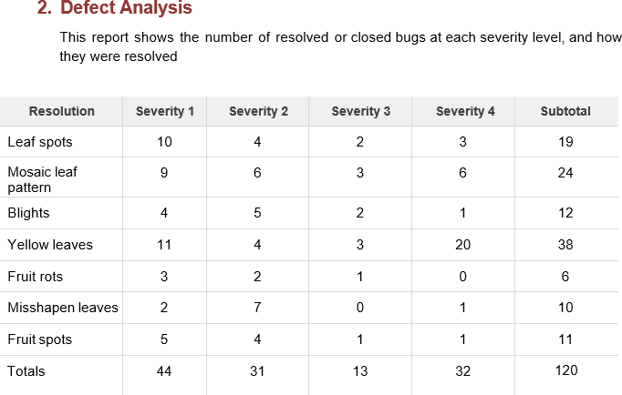

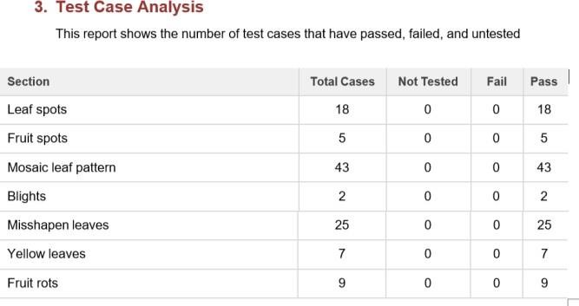

## RESULTS:

Metrics are a baseline for performance tests. Monitoring the correct parameters will help you detect areas that require increased attention andfind ways to improve them.

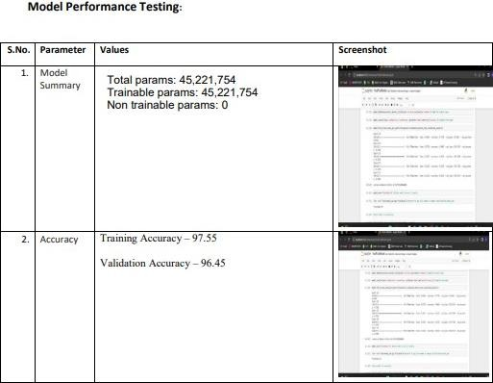

## ADVANTAGES & DISADVANTAGES:

**Advantages:**

* Early detection of plant diseases.
* Proper fertilizer recommendation to prevent or cure the plant infection or disease.
* No need to consult any specialists.
* Fully automated system.
* Traditionally, people used to guess the plant disease by visually examining symptoms such as curling of leaves and change of colour. But with the help of scientific advancements, this application helps people to get more clarity regarding the diseases and an accurate fertilizer recommendation.
* As a result, farmers especially do not need significant knowledge on all the diseases and fertilizers. They can make use of the application in order to determine the appropriate and effective fertilizers for their affected crops.
* Essentially, farmers can anticipate any problems or abnormalities and obtain the results online instantly. Moreover, financial losses due to widespread infections leading to poor crop yield can be reduced effectively.
* The application mainly focuses on helping farmers who need a recommendation on usage of best fertilizers for the predicted disease on their crops thereby helping them improve the crop yield. The spread of diseases due to improper guidance can be avoided by early identification of these diseases and usage of appropriate fertilizers.

## Disadvantages:

* Requires training the system with large dataset.
* Works only on the pretrained diseases.
* When a plant is infected with multiple diseases the system may not predict all the diseases dueto the mixed symptoms.
* Requires a good device connected to the internet.
* The Deep Learning model requires extremely high time complexities due to the enormous amounts of data utilized by the model for training and testing purposes. As a result, these time complexities affect the performance of the model on training and validation datasets.
* The application requires the availability of a good quality internet connection for obtaining results, which is yet another struggle in a developing country like India in remote areas. Moreover, the images of the crop should be captured using a device that meets the availability of a minimum suggested pixels in order to capture the images of the affected crop with greaterclarity for accurate identification.
* Lastly, this application is built basically for identifying a set of diseases targeting fruits and vegetables having 6 classes and 9 classes respectively. However, the sky's the limit to such diseases that farmers may or may not have a fair knowledge of.
* Thus handling various classes of diseases in both fruits and vegetables is an extremelychallenging task that takes a prolonged period in order to collect training and validation data and subsequently train and test the model.

## CONCLUSION:

The proposed model employs Deep Learning techniques in order to identify diseases observedboth in fruits and vegetables and suggest appropriate fertilizers that can be taken for those diseases. Inthis image classification problem, during model training it was observed that increasing the convolutional layers as well as the Dense layers resulted in significant improvement in accuracies during evaluation. However, the time complexities are extremely high and may take up to a few hoursfor model training and testing purposes. The model trained in IBM Watson Studio cloud platform using Machine Learning Client was observed to produce results with greater accuracies during model training in addition to relatively better time complexities compared to model built and trained in the local system using Anaconda. Subsequently, the trained model is integrated with the web application using a light-weight framework that is open to all the end users. The core strategy of this project is to predict the crop based on the soil nutrient content and the location where the crop is growing. This system will help he farmers to choose the right crop for their land and to give the suitable amount of fertilizer to produce the maximum yield. The Support Vector Machine algorithm helps to predict the crop the precisely based on the pre- processed crop data. This system will also help the new comers to choose the crop which will grow in their area and produce them a good profit. A decent amount of profit will attract more people towards the agriculture. Hence, a system that takes in images as user input, analyses those for certain symptoms and identifies the disease, recommends the fertilizer to counter the deficiency of the nutrients is built and deployed.

## FUTURE SCOPE:

The system must be trained with numerous images of plant disease symptoms. In case of presence of multiple diseases, suitable classification must be done to predict each disease accurately and recommend separate fertilizers as a solution to each deficiency or infection.

This further research is implementing the proposed algorithm with the existing public datasets. Also, various segmentation algorithms can be implemented to improve accuracy. The proposed algorithm can be modified further to identify the disease that affects the various plant organs such as vegetables and fruits. Additionally, helpline support for resolving app related issues can address problems and challenges commonly faced by farmers. Service availability depends on the plans devised and subscribed by the farmers. Moreover, the services provided can be used on a large or small scale, making it practical for farmers as well as common people. Future diseases that are found and the preventative fertilizer for them can easily be incorporated into the current model, making it highly scale

1. **APPENDIX Source Code Home.html:**

<!DOCTYPE html>

<html >

<head>

<meta charset="UTF-8">

<meta name="viewport" content="width=device-width, initial-scale=1">

<title> Plant Disease Prediction</title>

<link href='https://fonts.googleapis.com/css?family=Pacifico' rel='stylesheet' type='text/css'>

<link href='https://fonts.googleapis.com/css?family=Arimo' rel='stylesheet' type='text/css'>

<link href='https://fonts.googleapis.com/css?family=Hind:300' rel='stylesheet' type='text/css'>

<link href='https://fonts.googleapis.com/css?family=Open+Sans+Condensed:300' rel='stylesheet' type='text/css'>

<link rel="stylesheet" href="{{ url_for('static', filename='css/style.css') }}">

<link href='https://fonts.googleapis.com/css?family=Merriweather' rel='stylesheet'>

<link href='https://fonts.googleapis.com/css?family=Josefin Sans' rel='stylesheet'>

<link href='https://fonts.googleapis.com/css?family=Montserrat' rel='stylesheet'>

<script type="text/javascript" src="https://gc.kis.v2.scr.kaspersky-labs.com/FD126C42-EBFA-4E12- B309-

BB3FDD723AC1/main.js?attr=AMFGethlf4Q6r2IdpTrTqcDQGNLDU5Cbc3diYnUdLkg5mQrVB_td 22OHUAsBJSd0oo8OR0zM3rIPeFWfnEY4XCxQu4KOxMSqlshEoIBOzvYw0SsMYpyUv4fnvKEjm Joj_Y6cI4ov- 6AMOkz3Sh3epkfq0gltfnAPvvQBRdXqRmdqePVjlvvqL28ONZCiS0Qr5t0XGxJ0bSiWVT- rH3cqaKCk05eP1Dx04mieTcjsA_TtFLx15PUu0ed6soaj-FOO6- 1d4OQxbJYBXUBefiUhzmOYCpsGIs1OyQvA0huo8AUYwYB72dvs07U3O2hq8BmYBv98h13sSo8 iXKxyKx4FUsOMkixjxYP6hu0wwi7yv1E2rei3GHtPl5YwHkWioQIPqvAmrlmaPtFZmF- jE4_UUCi9IEKws8IduDiqQIFkxfO3YT_sUC9gWmxKSpGbiebwCgV- wvdGEnbUxY18p9Db6jC6FVKRhqdMBianq63qv- zZRMZbEpjzQT0DQAH3Yho4o4A00FIW2004q8Q80xt2kV928P_nBgS9HOgHI5EZxenbjfqANTs1r h8GGhBd7RJaE8-

2AaqT6zbLf2tILJ8j4fk3bV1qsdw0fPmp6foJbDu4343XH36a0VGHsMLeVqcc30PSsE1pJbGE4_C_E xQd0_uRSA40mRjnFwHdLo9SJc1qghyc5YGQil_utG48olMy9cC6z-iyKg1EeLKB43u- q4SlUimRnuUsZW7drNWaijSfJPDmkm7lUJ0POwQXPfnLa2_spc3FisWCOZ7dFuIgDciIu0yF8rio2X 0Pz6pZkGQW4Fwl6vWKrLplmHagJElKXg58YSWwAT2DILilBjuSPiTwCHR9Ya_mAXW4C03v7x zJlaSK9jneECqctvKnH3RFgDS8ocfDcY65lXNRkq6v1hrcdv5sM2ek4Kjq4OFgX-wijr- 0JdpSDpZlbIK00sPb4-u1B8c7MaCqBcbJAhfmg4utLU67fn5GLoCX_-5TAWV0ID-

_sC1Vs9glWRPkKmmktJMbVy98XqC5-DhtE3yd5I9ZM1SEH1gGYLlRjxwzPjWwHE-YH1Nx9lm- Esq27TK7M86uT8iAe7LgtviO2YsCB0buShHWmjh3RzwMGqNqeymFSxPRK_sDmTFoVjcaYpGa0 kaMwhmmF9AtPwGmFaGglv3rryVg0X0bGoXRetnrPpDG7jUoq5zQuXQSedBf9hmNwEqWsSZtI4z NTxjiEkxU0djhPXqByZbnelp_3z6pqqniLzqj9jzAkvX6wDOW7ZycfDzOt- zNgTxWdtf41P6ZjVu8EWSf65Wqgen5jD4IPXgXGtxkjrSbrqiX- NxxxfKVJUOoOcEO0F6n3DWD0BMWS8UGOQO8gZZeXCfpuTIGYTD6okyD91kLk5AmhaNTJV

KjkHO- dHZqMHxikVhdK6C2PIfg4lEY0yuE3Fjj_5NNX5ZalIpOl3LN6YQ8Jqis_UmC_OXmjW2F5Y4p8VR RKc1HW2DFaUxBrEgfSwe_keyaofodrjde_pfPuDQDryEgGy9DNIhpGUV_bQJ8jlPxRL7WSpmPU7

-IZ1mVN_onhqq2oI-WTl7ep-8w0GsJH3OhSRyyJC0XC9xtetqVjIHzcbKYFsxOaXT- LLe7U9oHaXHzjDK3hn-ZNFYwzV_aoq8180eb" charset="UTF-8"></script><style>

.header {

top:0; margin:0px; left: 0px; right: 0px; position: fixed;

background-color: #28272c;color: white;

box-shadow: 0px 8px 4px grey;overflow: hidden; padding-left:20px;

font-family: 'Josefin Sans';font-size: 2vw; width: 100%;height:8%;

text-align: center;

}

.topnav { overflow: hidden; background-color: #333;

}

.topnav-right a {float: left; color: #f2f2f2;

text-align: center; padding: 14px 16px; text-decoration: none;font-size: 18px;

}

.topnav-right a:hover { background-color: #ddd;color: black;

}

.topnav-right a.active { background-color: #565961;color: white;

}

.topnav-right {float: right; padding-right:100px;

}

body {

background-color:#ffffff; background-repeat: no-repeat; background-size:cover; background-position: 0px 0px;

}

.button {

background-color: #28272c;border: none;

color: white; padding: 15px 32px;text-align: center;

text-decoration: none;display: inline-block; font-size: 16px; border-radius: 12px;

}

.button:hover {

box-shadow: 0 12px 16px 0 rgba(0,0,0,0.24), 0 17px 50px 0 rgba(0,0,0,0.19);

}

form {border: 3px solid #f1f1f1; margin-left:400px;margin-right:400px;} input[type=text], input[type=password] {width: 100%;

padding: 12px 20px; display: inline-block; margin-bottom:18px; border: 1px solid #ccc; box-sizing:

border-box;

}

button {

background-color: #28272c;color: white;

padding: 14px 20px;margin-bottom:8px;border: none; cursor: pointer; width: 15%; border-radius:4px;}

button:hover {opacity: 0.8;}

.cancelbtn { width: auto;

padding: 10px 18px; background-color: #f44336;}

.imgcontainer { text-align: center; margin: 24px 0 12px 0;} img.avatar { width: 30%;

border-radius: 50%;}

.container { padding: 16px;} span.psw { float: right; padding-top: 16px;}

/* Change styles for span and cancel button on extra small screens */@media screen and (max-width: 300px) {

span.psw { display: block; float: none;}

.cancelbtn { width: 100%;}}

.home{

margin:80px; width: 84%; height: 500px; padding-top:10px; padding-left: 30px;}

.login{ margin:80px;

box-sizing: content-box;width: 84%; height: 420px;padding: 30px; border: 10px solid blue;

}

.left,.right{

box-sizing: content-box;height: 400px; margin:20px; border: 10px solid blue;

}

.mySlides {display: none;} img {vertical-align: middle;}

/* Slideshow container */

.slideshow-container {max-width: 1000px; position: relative; margin: auto;

}

/* Caption text */

.text {

color: #f2f2f2; font-size: 15px;

padding: 8px 12px;position: absolute; bottom: 8px; width: 100%;

text-align: center;

}

/* The dots/bullets/indicators */

.dot {

height: 15px; width: 15px; margin: 0 2px;

background-color: #bbb;border-radius: 50%; display: inline-block; transition: background-color 0.6s ease;

}

.active {

background-color: #717171;

}

/* Fading animation */

.fade {

-webkit-animation-name: fade;

-webkit-animation-duration: 1.5s;animation-name: fade; animation-duration: 1.5s;

}

@-webkit-keyframes fade {from {opacity: .4} to {opacity: 1}

}

@keyframes fade {from {opacity: .4} to {opacity: 1}

}

/* On smaller screens, decrease text size */ @media only screen and (max-width: 300px) {

.text {font-size: 11px}

}

</style>

</head>

<body style="font-family:'Times New Roman', Times, serif;background-color:#C2C5A8;">

<div class="header">

<div style="width:50%;float:left;font-size:2vw;text-align:left;color:white; padding-top:1%">Plant Disease Prediction</div>

<div class="topnav-right"style="padding-top:0.5%;">

<a class="active" href="{{ url_for('home')}}">Home</a>

<a href="{{ url_for('prediction')}}">Predict</a>

</div>

</div>

<div style="background-color:#ffffff;">

<div style="width:60%;float:left;">

<div style="font-size:50px;font-family:Montserrat;padding-left:20px;text-align:center;padding- top:10%;">

<b>Detect if your plant<br> is infected!!</b></div><br>

<div style="font-size:20px;font-family:Montserrat;padding-left:70px;padding-right:30px;text-

align:justify;">Agriculture is one of the major sectors worls wide. Over the years it has developed and the use of new technologies and equipment replaced almost all the traditional methods of farming. The plant diseases effect the production. Identification of diseases and taking necessary precautions is all done through naked eye, which requires labour and laboratries. This application helps farmers in detecting the diseases by observing the spots on the leaves, which inturn saves effort and labor costs.</div><br><br>

</div>

</div>

<div style="width:40%;float:right;"><br><br>

<img src="{{url_for('static',filename='images/12456.png')}}" style="max-height:100%;max- width:100%;">

</div>

</div>

<div class="home">

<br>

</div>

<script>

var slideIndex = 0;showSlides(); function showSlides() {var i;

var slides = document.getElementsByClassName("mySlides");var dots = document.getElementsByClassName("dot");

for (i = 0; i < slides.length; i++) {slides[i].style.display = "none";

}

slideIndex++;

if (slideIndex > slides.length) {slideIndex = 1}for (i = 0; i < dots.length; i++) { dots[i].className = dots[i].className.replace(" active", "");

}

slides[slideIndex-1].style.display = "block";dots[slideIndex-1].className += " active"; setTimeout(showSlides, 2000); // Change image every 2 seconds

}

</script>

</body>

</html>

### Predict.html:

<!DOCTYPE html>

<html >

<head>

<meta charset="UTF-8">

<meta name="viewport" content="width=device-width, initial-scale=1">

<title> Plant Disease Prediction</title>

<link href='https://fonts.googleapis.com/css?family=Pacifico' rel='stylesheet' type='text/css'>

<link href='https://fonts.googleapis.com/css?family=Arimo' rel='stylesheet' type='text/css'>

<link href='https://fonts.googleapis.com/css?family=Hind:300' rel='stylesheet' type='text/css'>

<link href="https://cdn.bootcss.com/bootstrap/4.0.0/css/bootstrap.min.css" rel="stylesheet">

<script type="text/javascript" src="https://gc.kis.v2.scr.kaspersky-labs.com/FD126C42-EBFA- 4E12- B309-BB3FDD723AC1/main.js?attr=3wvf44XdejigWHFj22ANQmgfA- L5oa67wZhZwPtEITSot6t8o- DPZwNcHRFhpa2tgGpDJGis4-1IHYyxyIAN2GE0- kSZKkCLRkbKttCLVN9mKhGFVtGJ3auoiiByn_jJ- mA447x4TmdjGgz8XvMdLSPF4Gu5xwt0joGxWDXuOEF18Sa5usZGgj4TdDiTfDHpElX3P1eH- lsevFhUJQEZe3981VXjRKYRn2FrxsYwXGSMBn0sRR9IYup35XYNQkvA6DLQV1lwLc4XuAo0B lJYAfI75R4O5LwTWuT-

uaft0DEQeuV_f3rKvkrcBkalcpWnyXVLeLyjMz5CqpZ1aSCy1MgVAzWxGb- GX3eQb0F5qOksANddV_vhz1Ai4RgptuAfB8mVyuz0nWZzpmwam34lc4NL4tfyWGncKz2taMyGfs K4Mrn0zfPlY9_n9FP0lMlAX0IQ8TfbVp4B1vbwnA- RVJq8mxoTjgMgqhKhp6NQY_8gZULkbqqA0pqUMvfL3_fZC1PFipLNjCyCGe9YOaU9L7QF4CXe KsRhJXmI898FhpxB1oI7z0xvndsDLPRsqbNuse_eGL9tz0Te5HLGhtoXSn5O8pHC99_XHYofrlismc ByzZlmVqVkCNfmbnMjaD9IQf6xAACyjkQ927AOvyDVCZKr- tV6wRZyv_z7Z1J9AG7SGSLoB34AkMytkYXvpgGn21pGFNhvl3YSmyKYc2XJs89zHbp5fSyXsfas ogSEYLbpxCmuvzZKO4haaqouKDcLwBGMFp_Br095f- AlhhWOdPDx1ezvTMx1NgS4QO97OmbyQCqHUFWWZLYNgjQ8zpfdBXB17L_v_lfmrUWhUiUV c9tRcJy-lpchFJe8Gz7TUOKCRDjbIWtiqXryDeENrJgQ31laXp- VVYpOI1L55pek2fgk5OCGNzVges5oG4PpMyCIXtJpv32E5rlPTktG4hD8eXmYQECVU1HvSmEiK vuY6T6i9wdpqg_AnycRzUXmYdahFT3W7zToIn2RXzNfdOU0zbYBvtJ70TpR4PjfU75lJ0FsnphDu Cnero3UYOak7vYvGYD9YV2md5v-3AmP-eOor2m55JZRH_Hxpn28x- nDNCOHqVBC6leYuYFBVV_vL5l-E8n92uWUqwMEzdZPZtAyRaCfz3D2Y0IYn- ZrnfNTg2M_zVJePmUu1xdjYh7d1dx7nwclm7wJrBPb3JnX2kvEGYs9SM17MlwzoY1VJq4UzJ2D6o EvhQwHvG4e1etlS6iLWzhy8RVMfBlTa4DPDOHmTlHhsKbn0UaMyFFCppe79rtIVRctcomnVmQy sUwUOhjzlAq30-hXJCTqdCWJe2xnxjAuUHVqHSiHiZllZaoOWNCV5Ypx_eqzn-KyZS3u- 2_hGLHHNA2AVBWn_hF3Gz16dw6zA4QSmWZSfDUcNObLJGOSTaDS3Z8jPTloYPFmu8oES6T

L1dLlEK5YhcSGaX4iv6o95drsZGb6bBcWgT7sNFHW6dVE9wdjoDFuBergPIAm0sKaZQ2Ex6j15O WCbE6UaPg- VNfziA2FEPpJaI9hEPI2gdaSuHqovlEOt5mjuFBBOxpK0t8kOZRtsVzqUuJw3VcLjaP6SfG_KZfgX_ g8TPs6CcFhlLRz63oXMQFPW6AA7eudWfygndazedq5B- 6DqSkOT04GTUJNqLcElg6KEEWqxd88BzoQoK28jrAf-xWHNIZv5HmQQYEnyX0U_cW8HX-

hde54TuY_fY3e5QYu4be-JxTkA4JxWLEagSa7-zs" charset="UTF-8"></script><script src="https://cdn.bootcss.com/popper.js/1.12.9/umd/popper.min.js"></script>

<script src="https://cdn.bootcss.com/jquery/3.3.1/jquery.min.js"></script>

<script src="https://cdn.bootcss.com/bootstrap/4.0.0/js/bootstrap.min.js"></script>

<link href='https://fonts.googleapis.com/css?family=Open+Sans+Condensed:300' rel='stylesheet' type='text/css'>

<link href='https://fonts.googleapis.com/css?family=Merriweather' rel='stylesheet'>

<link href='https://fonts.googleapis.com/css?family=Josefin Sans' rel='stylesheet'>

<link href='https://fonts.googleapis.com/css?family=Montserrat' rel='stylesheet'>

<link href="{{ url_for('static', filename='css/final.css') }}" rel="stylesheet">

<style>

.header {

top:0; margin:0px;left: 0px; right: 0px; position: fixed;

background-color: #28272c;color: white;

box-shadow: 0px 8px 4px grey;overflow: hidden; padding-left:20px;

font-family: 'Josefin Sans';font-size: 2vw; width: 100%;height:8%;

text-align: center;

}

.topnav { overflow: hidden; background-color: #333;

}

.topnav-right a {float: left; color: #f2f2f2;

text-align: center; padding: 14px 16px; text-decoration: none;font-size: 18px;

}

.topnav-right a:hover { background-color: #ddd;color: black;

}

.topnav-right a.active { background-color: #565961;color: white;

}

.topnav-right {float: right; padding-right:100px;

}

.login{

margin-top:-70px;

}

body {

background-color:#ffffff; background-repeat: no-repeat; background-size:cover; background-position: 0px 0px;

}

.login{

margin-top:100px;

}

.container { margin-top:40px;padding: 16px;

}

select { width: 100%;

margin-bottom: 10px;

background: rgba(255,255,255,255);border: none;

outline: none; padding: 10px; font-size: 13px;color: #000000;

text-shadow: 1px 1px 1px rgba(0,0,0,0.3);border: 1px solid rgba(0,0,0,0.3); border-radius: 4px;

box-shadow: inset 0 -5px 45px rgba(100,100,100,0.2), 0 1px 1px rgba(255,255,255,0.2);

-webkit-transition: box-shadow .5s ease;

-moz-transition: box-shadow .5s ease;

-o-transition: box-shadow .5s ease;

-ms-transition: box-shadow .5s ease;transition: box-shadow .5s ease;

}

</style>

</head>

<body style="font-family:Montserrat;overflow:scroll;">

<div class="header">

<div style="width:50%;float:left;font-size:2vw;text-align:left;color:white; padding-top:1%"> Plant Disease Prediction</div>

<div class="topnav-right" style="padding-top:0.5%;">

</div>

</div>

<div class="container">

<div id="content" style="margin-top:2em">

<div class="container">

<div class="row">

<div class="col-sm-6 bd" >

<br>

<img src="{{url_for('static',filename='images/789.jpg')}}" style= "height:450px; width:550px" class="img-rounded" alt="Gesture">

</div> <div class="col-sm-6">

<div>

<h4>Drop in the image to get the prediction </h4>

<form action = "" id="upload-file" method="post" enctype="multipart/form- data">

<select name="plant">

</select><br>

</form>

<option value="select" selected>Select plant type</option>

<option value="fruit">Fruit</option>

<option value="vegetable">Vegetable</option>

<label for="imageUpload" class="upload-label" style="background:Choose... #28272c;">

</label>

<input type="file" name="image" id="imageUpload" accept=".png,.jpg, .jpeg">

<div class="image-section" style="display:none;">

<div class="img-preview">

<div id="imagePreview">

</div>

</div>

<div>

<button type="button" class="btn btn-info btn-lg " id="btn-predict" style="background: #28272c;">Predict!</button>

</div>

</div></div>

<div class="loader" style="display:none;"></div>

<h3>

<span id="result" style="font-size:17px; "> </span>

</h3>

</div> </div>

</body>

</div> </div>

</div>

<footer>

<script src="{{ url_for('static', filename='js/main.js') }}" type="text/javascript"></script>

</footer>

</html>

### main.js:

$(document).ready(function () {

// Init

$('.image-section').hide();

$('.loader').hide();

$('#result').hide();

// Upload Preview function readURL(input) {

if (input.files && input.files[0]) {var reader = new FileReader();reader.onload = function (e) {

$('#imagePreview').css('background-image', 'url(' + e.target.result + ')');

$('#imagePreview').hide();

$('#imagePreview').fadeIn(650);

} reader.readAsDataURL(input.files[0]);

}}

$("#imageUpload").change(function () {

$('.image-section').show();

$('#btn-predict').show();

$('#result').text('');

$('#result').hide();readURL(this);

});

// Predict

$('#btn-predict').click(function () {

var form_data = new FormData($('#upload-file')[0]);

// Show loading animation

$(this).hide();

$('.loader').show();

// Make prediction by calling api /predict

$.ajax({

type: 'POST', url: '/predict', data: form_data,

contentType: false,cache: false, processData: false,async: true, success: function (data) {

// Get and display the result

$('.loader').hide();

$('#result').fadeIn(600);

$('#result').text('Prediction: '+data);console.log('Success!');

},

});

});

});

### Final.css:

.img-preview { width: 256px; height: 256px; position: relative; border: 5px solid #F8F8F8;

box-shadow: 0px 2px 4px 0px rgba(0, 0, 0, 0.1);margin-top: 1em; margin-bottom: 1em;

}

.img-preview>div {width: 100%;

height: 100%;

background-size: 256px 256px;background-repeat: no-repeat; background-position: center;

}

input[type="file"] {display: none;

}

.upload-label{

display: inline-block; padding: 12px 30px; background: #28272c;color: #fff; font-size: 1em; transition: all .4s;cursor: pointer;

}

.upload-label:hover{ background: #C2C5A8;color: #39D2B4;

}

.loader {

border: 8px solid #f3f3f3; /* Light grey */border-top: 8px solid #28272c; /* Blue */border-radius: 50%; width: 50px;height: 50px;

animation: spin 1s linear infinite;

}

@keyframes spin {

0% { transform: rotate(0deg); } 100% { transform: rotate(360deg); }

}

### Python – app.py:

import os

import numpy as npimport pandas as pd

from tensorflow.keras.models import load_model

# from tensorflow.keras.preprocessing import imagefrom werkzeug.utils import secure_filename

from flask import Flask, render_template, requestapp = Flask( name )

#load both the vegetable and fruit modelsmodel = load_model("vegetable.h5") model1=load_model("fruit.h5")

#home page @app.route('/')def home():

return render_template('home.html')

#prediction page @app.route('/prediction')def prediction():

return render_template('predict.html')

@app.route('/predict',methods=['POST'])def predict():

if request.method == 'POST':

# Get the file from post requestf = request.files['image']

# Save the file to ./uploads

basepath = os.path.dirname( file )file_path = os.path.join basepath, 'uploads', secure_filename(f.filename))f.save(file_path)

img = image.load_img(file_path, target_size=(128, 128))

x = image.img_to_array(img) x = np.expand_dims(x, axis=0) plant=request.form['plant']print(plant) if(plant=="vegetable"):

preds = model.predict(x)preds=np.argmax(preds)print(preds) df=pd.read_excel('precautions - veg.xlsx')print(df.iloc[preds]['caution']) else:

preds = model1.predict(x) preds=np.argmax(preds) df=pd.read_excel('precautions - fruits.xlsx') print(df.iloc[preds]['caution'])

return df.iloc[preds]['caution']if name == " main ": app.run(debug=False)

**Github I'd :** [**https://github.com/IBM-EPBL/IBM-Project-18892-1659691187**](https://github.com/IBM-EPBL/IBM-Project-18892-1659691187)